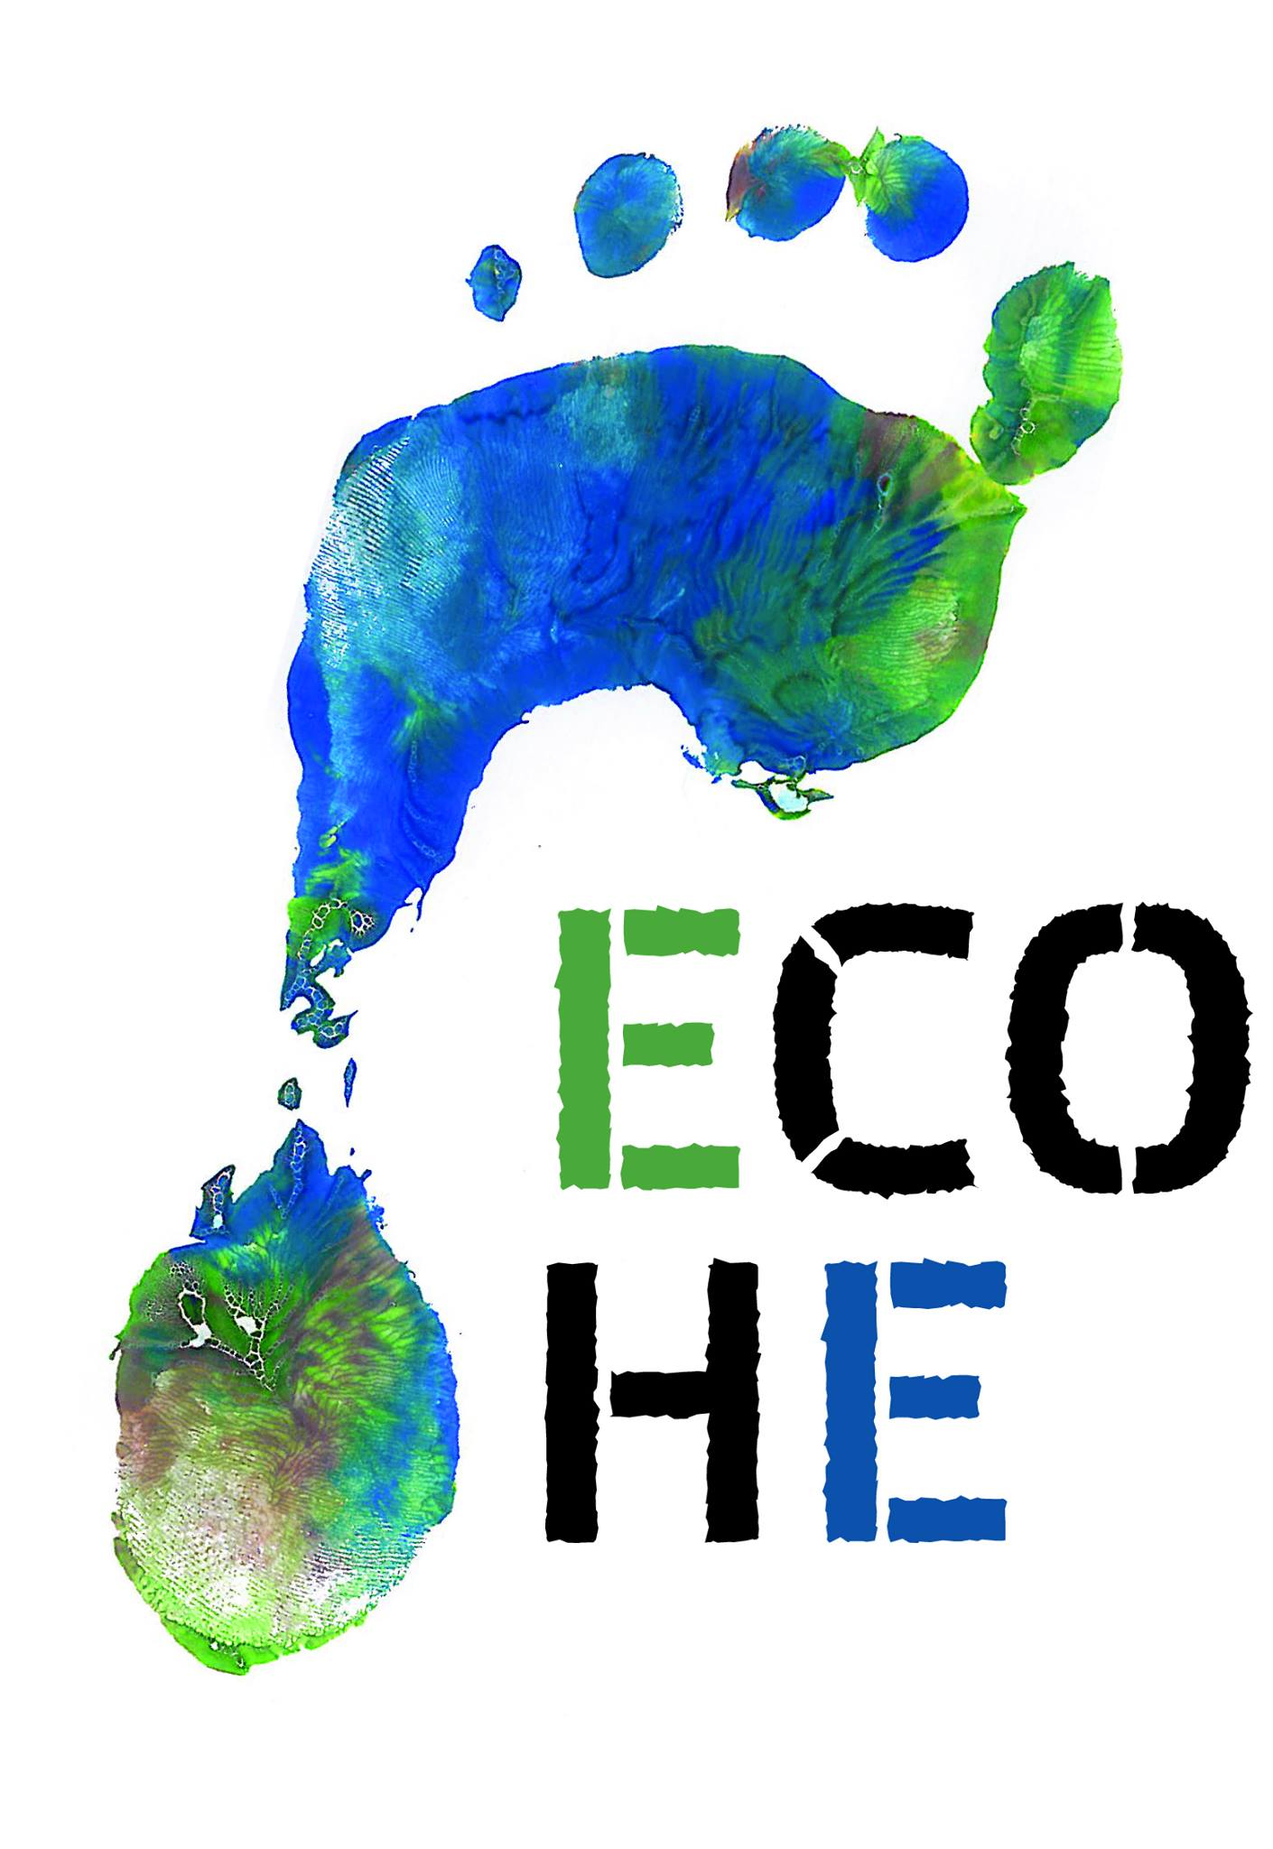

Eco-Hiking Europe
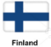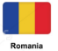
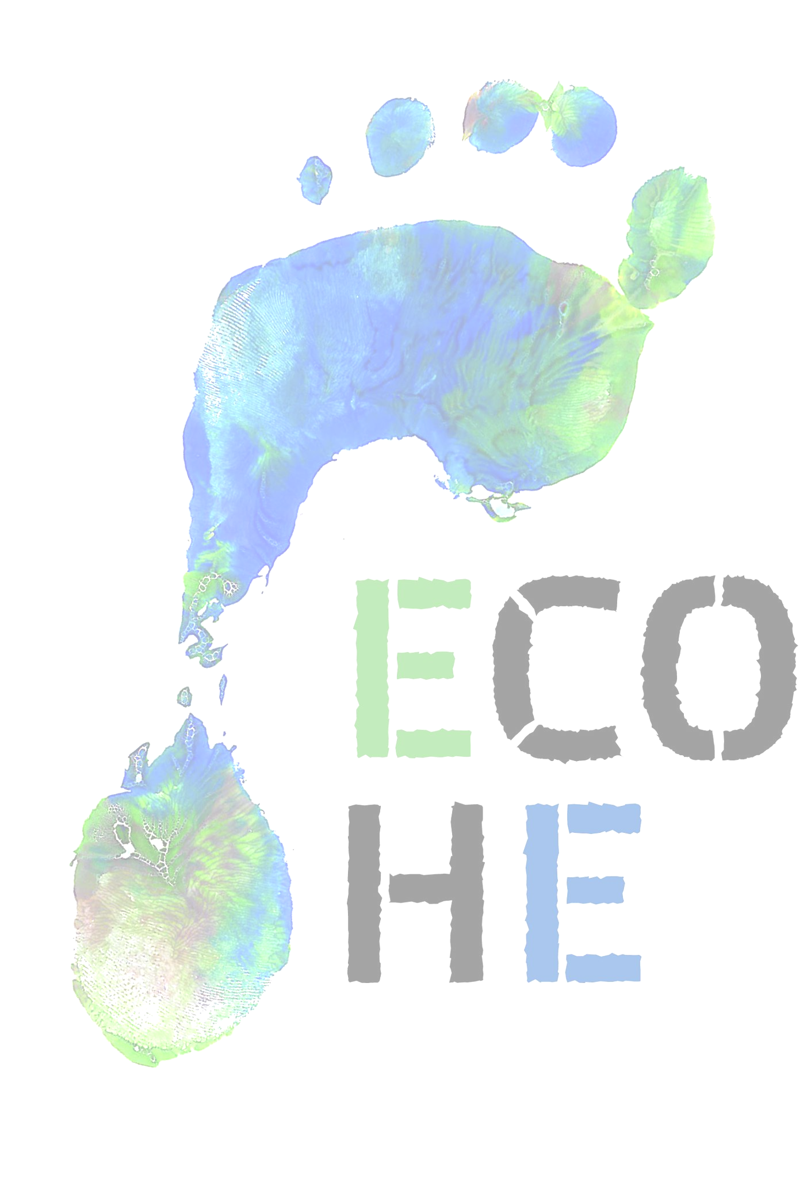
9-13 October, 2017

Karlovy Vary, the Czech Republic
30 participants from 5 countries will Ecohike once again. After hiking in Crete, Portugal and Finland, this time we will hike in the Czech Republic. We will spend Monday-Thursday outdoors. On Friday we will visit the host school, SUPŠKV. Come meet us…

www.ecohikingeurope.webnode.cz

